TMT/Agra /S0779/2026 07.05.2026

To,
Vivek Sharma
Gurukripa Enterprises, PLOT NO.9,
GURUKRIPA TOWN COLONY, VILLAGE-PANCHGAI KHEDA,
DEORI ROAD,AGRAVILLAGE-PANCHGAI
KHEDA PLOT NO.9 DEORI ROAD,282009,Agra, Agra - 282001, UP
Click to Call: +91-9870709589
E-mail: vivek146922@gmail.com

Dear sir,

Sub: - Supply of Roll Forming Machines.

TOP HAT PROFILE ROLL FORMING

S.NO | SCOPE OF SUPPLY | QTY
1 | Stands | 16passes
2 | Shafts Ø 50 | 32NOS
3 | Rollers hat- Section | 2Set
4 | Cutting Tool | 2Set
5 | Motor 20HP | 1Set
6 | Run of Table | 1NOS
7 | PLC HMI DRIVE | 1Set
8 | D Coiler 5Ton | 1Set
9 | Gear Box6” | 4NOs
10 | Cutting power Pack 7.5HP | 1Set
11 | 20Ton Cylinder | 1Set
12 | Machine Forming Bed(1+1) | 1Set
13 | Online Punching With 2kw Servo Motor | 1Set
14 | Punching Power Pack 10HP, With 3Cyliders | 1Set
15 | Punching Tools | 4 Sets
16 | Sheet Leveller With Gear Box & Motor | yes
17 | Lopping system Width 500mm,Depth 3mtrs | yes
18 | Entry Guide | 450mm length
19 | delivery Guide | turkstyle
20 | Servo Stands | na
21 | Section Size  (40 x height 40-120 mm x thickness upto 1.6 mm )
 | Price | 40,00,000=00

S.NO | SCOPE OF SUPPLY FOR C MACHINE | QTY
1 | Stands 60mm thickness | 14passes
2 | Shafts Ø 70 | 28NOs
3 | Roller C-Section | 1Set
4 | Cutting Tool (Any Size 3Ses) | 3Sets
5 | Motor 20HP | 3Sets
6 | Run Of Table | 2NOS
7 | PLC HMI DRIVE | 1Set
8 | D coiler 3Ton | 1Set
9 | Gear Box7” | 3NOs
10 | Cutting Power Pack12.5HP | 1Set
11 | 50 Ton Cylinder | 1Set
12 | Machine Forming Bed(1+1) | 1SET
13 | Online punching with5kw Servo Motor | 1Set
14 | Punching Power Pack 15HP, With 5Cylinders, oil Cooler | 1Set
15 | Punching Tools | 5Sets
16 | Section Size  (a)Web 50 to 250mm,  (b)Flange 40 to 80mm,  (C)Lip 10 to 25mm,Thickness 2.5mm
17 | Lopping System Width 500mm, Depth 3mtrs, Length4mtrs
18 | Sensors | 5Sets
19 | Servo Stand With Rollers 400mm Working Area | 1Set
 | Price | 44,00,000
“C” PURLIN PROFILE ROLL FORMING

S.NO | SCOPE OF SUPPLY FOR C MACHINE | QTY
1 | Stands 50mm thickness | 8 passes
2 | Shafts Ø 50 | 16 NOs
3 | Roller L-Section | 1 Set
4 | Cutting Tool upto 60x60x2.5 mm | 1 set
5 | Motor 10HP | 1Sets
6 | Run Of Table | 2NOS
7 | PLC HMI DRIVE | 1Set
8 | D coiler 3Ton | 1Set
9 | Gear Box5” | 1NOs
10 | Cutting Power Pack .5HP | 1Set
11 | 20 Ton Cylinder | 1Set
12 | Machine Forming Bed(1) | 1SET
16 | Section Size  (a)upto 60x60 mm,  ((b)Thickness 2.5mm
18 | Sensors | 3Sets
 | Price | 11,00,000
“L” ANGLE ROLL FORMING

GENERAL TERMS & CONDITIONS:

- Price quoted per unit ex-work. Hyderabad.
- Following charges are additional to your account.
- Freight Charge : As actual to be borne by you.
- Sales Tax : 18% Extra as applicable
- Packing charge : As actual to be borne by you.
- Insurance : As actual to be borne by you.
- Payment : 50% advance along with order,
: balance 50% after installation and before delivery
- Delivery : within 8 weeks from date of advance received
- Validity : One month from the date of submission.
- Inspection : Inspection at our works prior to dispatch.
- Warranty : The machine is warranted for a period of 12 months from the date of dispatch against any manufacturing defects/ faulty material or bad workmanship of any part or component but not against any kind of abnormal or improper use of machine. Defective part or component will be replaced or repaired free of cost. Electrical components are outside the scope of this warranty.
- Commissioning : Erection & commissioning done by you, but required technical support & guidance provide by us at additional cost.

NOTE:
- Oil is not in scope of our supply.
- Raw material for trial is to be arranged by you at your cost.

We are sure you will find our offer in line with your requirements. Should you require any further clarification please contact T. Sivaramakrishna 9246221106. Email: techno9246221106@gmail.com WhatsApp No: 9849207176

Thanking you and assuring you of our best services.

For TECHNO MACHINE TOOLS

( T. SIVARAMAKRISHNA)

TMT/Agra /S0779/2026 07.05.2026

To,
Vivek Sharma
Gurukripa Enterprises, PLOT NO.9,
GURUKRIPA TOWN COLONY, VILLAGE-PANCHGAI KHEDA,
DEORI ROAD,AGRAVILLAGE-PANCHGAI
KHEDA PLOT NO.9 DEORI ROAD,282009,Agra, Agra - 282001, UP
Click to Call: +91-9870709589
E-mail: vivek146922@gmail.com
Sir,

Subject : Design, Manufacturing, Supply, (including structure) of 10 Ton Cap gantry Crane - Reg.

1. Design, Fabrication, Supply and Erection of Per Set Rs. 18, 00,000/-
10 ton EOT Crane as per following Specs.

General Specifications

- Type of Crane : Single Girder Electrically Operated Crane
Conforming to IS 3177 and 807
- Capacity of the gantry : 10 Tons

- Span of the gantry : 20 mts

- Lift of the gantry : 8.5 mts

- Type of Service : Indoor

- Class ( Mech / Elec ) : Class II

- Mode of Operation : Pendent Operated

- Type of Arrangement : Single Girder Box Type

- Ambient Temp. Considered : 45 Deg C



Lifting Equipment Specifications for 10 ton Unit

- Type of Hoist Proposed : 10 Ton Cap Wire Rope Hoist

- Type of Gear Box Casing Used : Totally Enclosed type Fabricated Stress
Relieved and Machined

- Material used for gears used in crane : Machine Cut Helical Gears Hardened
and Tempered
- Lubrication Provided for Gear Box : Splash Type Lubrication

- Bearing Used in the Gear Box : Self Aligned Anti Friction type Spherical
Roller Bearings
- Size and Make of Wire Rope : Dia 12 mm x 6/36 Const FM Core-Usha Martin

- Hoisting Speed : 3 mts/min

- Type of Hook : C type Hook conforming to IS 3815

- Class ( Mech / Elec ) : Class II

- Lift of the Hoist : 6 mts

- No. of Falls : 4 falls

- Rope Drum : Fabricated using Low Carbon Steel / Seam less
Pipe conforming to IS 2062 and duly stress relieved

- Motor Used : Sq Cage Induction Motor Crane duty– 6 pole
Class F/7.5 HP/40% CDF/150 Starts/hr -
BB/Siemens Make
- Type of Brake Used : EHT Brake– Dia 150 mm – 1 no of SOC Make

Type of Limit Switch Provided : Rotary Geared Type

Cross Travel Trolley

- Class of Duty ( Mech /Elec) : Class II

- No. Of Driver : 1 no

- C T speed : 12 mts/min

- Motor Used : Sq Cage Induction Motor Crane duty– 6 pole
Class F/2 HP/40% CDF/150 Starts/hr -
BB Make
- Type of Drive Proposed for Cross Travel : Floating Shaft Type Drive

- Wheel Housings used for CT : Bracket Type

Type of Limit Switch Provided : Shunt –2 Way Roller Leaver Type

- Specification of Wheels Used for CT : C 55 Mn 75 Forged Steel and Hardened to
30 HRC with diameter of 160 mm

Long Travel Trolley

- Class of Duty ( Mech /Elec) : Class II

- No. Of Driver : 1 no

- L T Speed : 15 mts/min

- Type of Drive Proposed for Long Travel : Twin Drive

- Motor Used : Sq Cage Induction Motor Crane duty– 6 pole
Class F/2 HP/40% CDF/150 Starts/hr -
BB Make

- Wheel Housings used for LT : Bracket Type

- Specification of Wheels Used for LT : C 55 Mn 75 Forged Steel and Hardened to
30 HRC with diameter of 300 mm

- Rail Size Considered for LT : 50 mm Sq Bar

Structure Considered for fabrication

- Platform : NA

- Girder for C T beam : Fabricated box type using M S plates

- End Carriages : Fabricated box type using M S Plates

- Type of Trail Cabling for Cross Travel : Through Flexible Trail Cabling

- Material used for Fabrication of crane : M S Conforming to IS 2062

- Painting Details : Two Coats of ROMP – two Coats
Enamel paint
- Safety features incorporated in system : Limit Switches for Hoist, LT, CT will be
provided

Electrical and Other Specifications

- Control Panel : Own make fabricated

- Cables used : Flexible copper cables
- Limit Switches : Reputed Makes will be used

2. Fabrication and Supply of Bus Bar Arrangement Rs. 1600/mt
for Electrical supply as per the Following Specs.

- Total Length of the Bus Bar : As Per Your Requirement

- Safe track type of enclosed Bus Bar : Safe track

- Capacity of the Bus Bar : 60 amps - GI

- Section used for the Bus Bar Brackets : Enclosed U type channel

EXCLUSIONS:

ALL CIVIL WORKS ARE NOT INTO OUR SCOPE OF SUPPLY
RAILS ARE NOT OUR SCOPE OF SUPPLY
ERRECTION EXTRA

GENERAL TERMS & CONDITIONS:

- Price quoted per unit ex-work. Hyderabad.
- Following charges are additional to your account.
- Freight Charge : As actual to be borne by you.
- Sales Tax : 18% Extra as applicable
- Packing charge : As actual to be borne by you.
- Insurance : As actual to be borne by you.
- Payment : 50% advance along with order balance before delivery but after inspection at our works.
- Delivery : with 50% advance with in 3 months.
- Validity : One month from the date of submission.
- Inspection : Inspection at our works prior to dispatch.
- Warranty : The machine is warranted for a period of 12 months from the date of dispatch against any manufacturing defects/faulty material or bad workmanship of any part or component but not against any kind of abnormal or improper use of machine. Defective part or component will be replaced or repaired free of cost. Electrical components are outside the scope of this warranty.
- Commissioning : Erection & commissioning done by you, but required technical support & guidance provide by us at additional cost.

NOTE:
- Oil is not in scope of our supply.
- Raw material for trial is to be arranged by you at your cost.

We are sure you will find our offer in line with your requirements. Should you require any further clarification please contact sivaramakrishna 9246221106.Email: md@technomachinetools.in
Thanking you and assuring you of our best services.

For Techno Machine Tools

T.SIVARAMAKRISHNA

TMT/Agra /S0779/2026 07.05.2026

To,
Vivek Sharma
Gurukripa Enterprises, PLOT NO.9,
GURUKRIPA TOWN COLONY, VILLAGE-PANCHGAI KHEDA,
DEORI ROAD,AGRAVILLAGE-PANCHGAI
KHEDA PLOT NO.9 DEORI ROAD,282009,Agra, Agra - 282001, UP
Click to Call: +91-9870709589
E-mail: vivek146922@gmail.com

Dear Sir,

Sub: - CONSTRUCTION OF SHED WITH CIVIL WORKS.

With reference to our telephonic conversation regarding your requirement of shed construction. We are glad to inform you that we would be in a position to supply you the required equipment. Given below are the required specifications and description of the machine and our terms and conditions.

Prices

SNO | DESCRIPTION | QTY | RATE/SFT | GROSS
1 | Length: 140 feet  Width : 50 feet 1 bays | 10000 SFT | Rs 998/- | 99,80,000=00

- All civil works into our account
- Erecting charges inclusive.

GENERAL TERMS & CONDITIONS:

- Price quoted per unit ex-work. Hyderabad.
- Following charges are additional to your account.
- Freight Charge : As actual to be borne by you.
- Sales Tax : 18% Extra as applicable
- Packing charge : As actual to be borne by you.
- Insurance : As actual to be borne by you.
- Payment : 50% advance along with order,
: balance 50% after installation and before delivery
- Delivery : within 2 weeks from date of advance received
- Validity : One month from the date of submission.
- Inspection : Inspection at our works prior to dispatch.
- Warranty : the shed is warranted for 10 years minion
- Commissioning : Erection & commissioning done by you, but required technical support & guidance provide by us at additional cost.

NOTE:
- Oil is not in scope of our supply.
- Raw material for trial is to be arranged by you at your cost.

We are sure you will find our offer in line with your requirements. Should you require any further clarification please contact T. Sivaramakrishna 9246221106. Email: md@technomachinetools.in WhatsApp No: 9849207176

Thanking you and assuring you of our best services.

For TECHNO MACHINE TOOLS

( T. SIVARAMAKRISHNA)

TMT/Agra /S0779/2026 07.05.2026

To,
Vivek Sharma
Gurukripa Enterprises, PLOT NO.9,
GURUKRIPA TOWN COLONY, VILLAGE-PANCHGAI KHEDA,
DEORI ROAD,AGRAVILLAGE-PANCHGAI
KHEDA PLOT NO.9 DEORI ROAD,282009,Agra, Agra - 282001, UP
Click to Call: +91-9870709589
E-mail: vivek146922@gmail.com

Dear sir,

Sub :- Supply of 50 MT C-TYPE HYDRAULIC PRESS.

This is reference to your enquiry for the hydraulic press; we offer our least possible price as under.

C TYPE PRESS :

1) Tonnage : 50 MT.
2) bed size : 550x550 mm

S No | Description of the unit | Offer
1. | C Type Hydraulic Press with capacity 50 Metric tons. with Power pack of 10 HP motor and with complete electrical.  Hydraulic power pack along with motor 10 hp motor  Tank 200 lts  Yuken vane pump 180 lpm  Piston pump 30.0 lpm  Pressure guage 1 No  Level indicator 1 No  Section filter 1 No  Return line filter 1 No  Section strainer 1 no  Manifold block 1 no  Pressure control valve 1 no  Solenoid operated direction control valve 1 nos  Pipes and fittings.  Bell housing 1 no  Pressure guage 0-250 kg 1 no  Flexible houses 2 nos  Nylon gear coupling 1 no  Bed size : 550x550 mm  Stroke : 150 mm  Day light : 350 mm | Rs 5,80,000/-  (Rupees Five Lakhs Eighty Thousand only)

SPECIFICATIONS FOR THE HYDRAULIC PRESS MACHINE WITH 80MT
1. Tonnage : 80 M.T.
2. Clearance between Housings : 450mm

3. Daylight : 800 mm

4. Ram stroke. : 350 M.M.

5. Open height. : 750 M.M.

6. Closed height. : 300 M.M.

7. Depth of Throat. : 450 M.M.

- Ram speeds.

a) Approach. : 12 M.M. per Sec.

b) Pressing. : 2 M.M. per Sec.

c) Return. : 20 M.M. per Sec.

9. Motor capacity. : 15 H.P. (Crompton)

10. Bed size. : 750 x 550 M.M.

12. Cost of Machine. : Rs.5,80,,000/- + Taxes.

13. Mode of payment. : As per the quotation.

14. Delivery. : As per the quotation.

For TECHNO MACHINE TOOLS

T.SIVARAMAKRISHNA
GENERAL TERMS & CONDITIONS:

- Price quoted per unit ex-work. Hyderabad.
- Following charges are additional to your account.
- Freight Charge : As actual to be borne by you.
- Sales Tax : 18% Extra as applicable
- Packing charge : As actual to be borne by you.
- Insurance : As actual to be borne by you.
- Payment : 50% advance along with order,
: balance 50% after installation and before delivery
- Delivery : within 2 weeks from date of advance received
- Validity : One month from the date of submission.
- Inspection : Inspection at our works prior to dispatch.
- Warranty : the shed is warranted for 10 years minion
- Commissioning : Erection & commissioning done by you, but required technical support & guidance provide by us at additional cost.

NOTE:
- Oil is not in scope of our supply.
- Raw material for trial is to be arranged by you at your cost.

We are sure you will find our offer in line with your requirements. Should you require any further clarification please contact T. Sivaramakrishna 9246221106. Email: md@technomachinetools.in WhatsApp No: 9849207176

Thanking you and assuring you of our best services.

For TECHNO MACHINE TOOLS

( T. SIVARAMAKRISHNA)

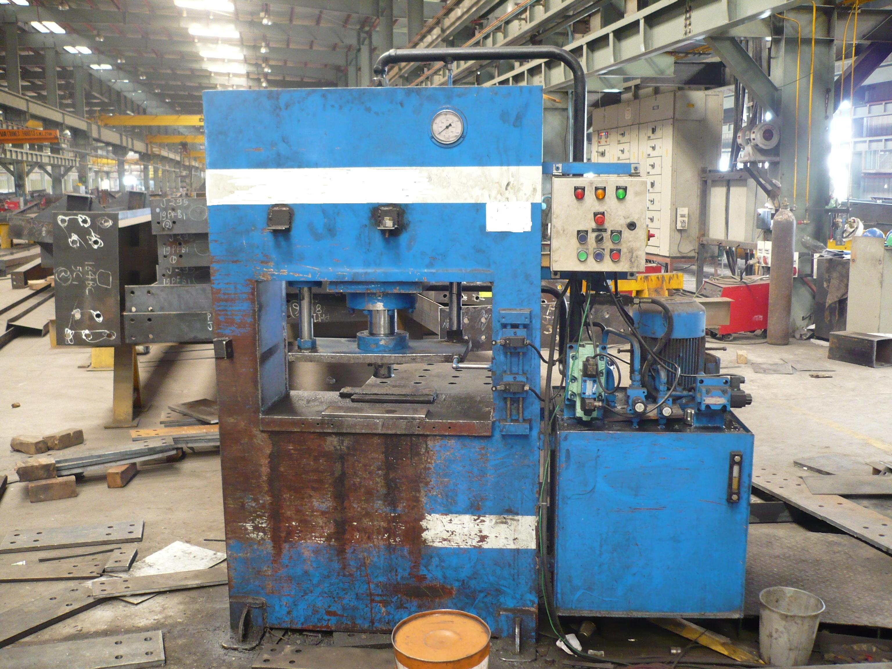

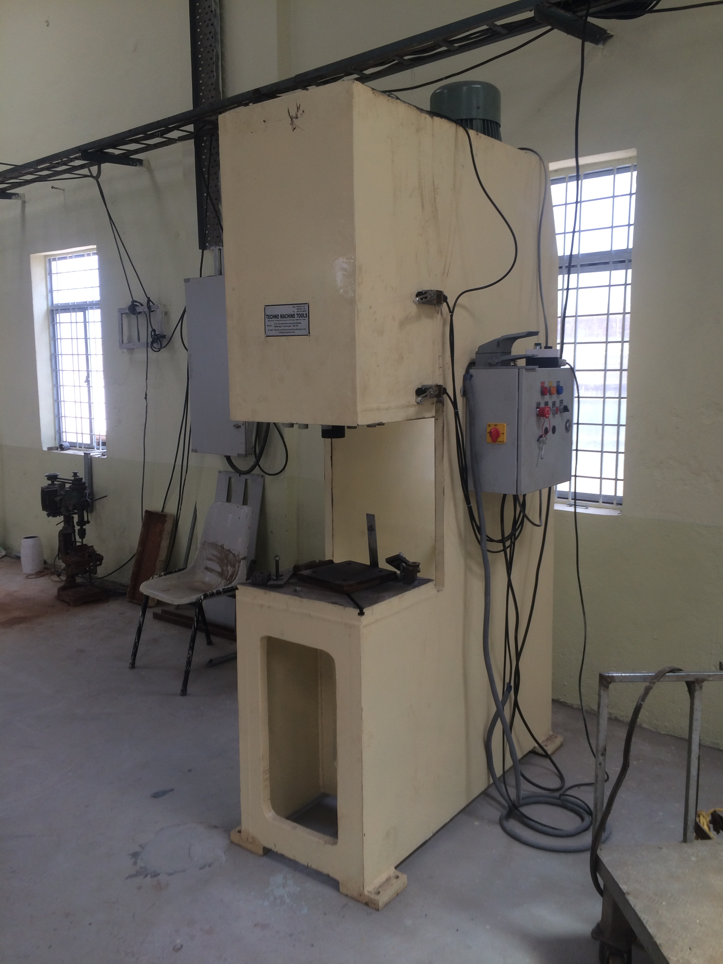

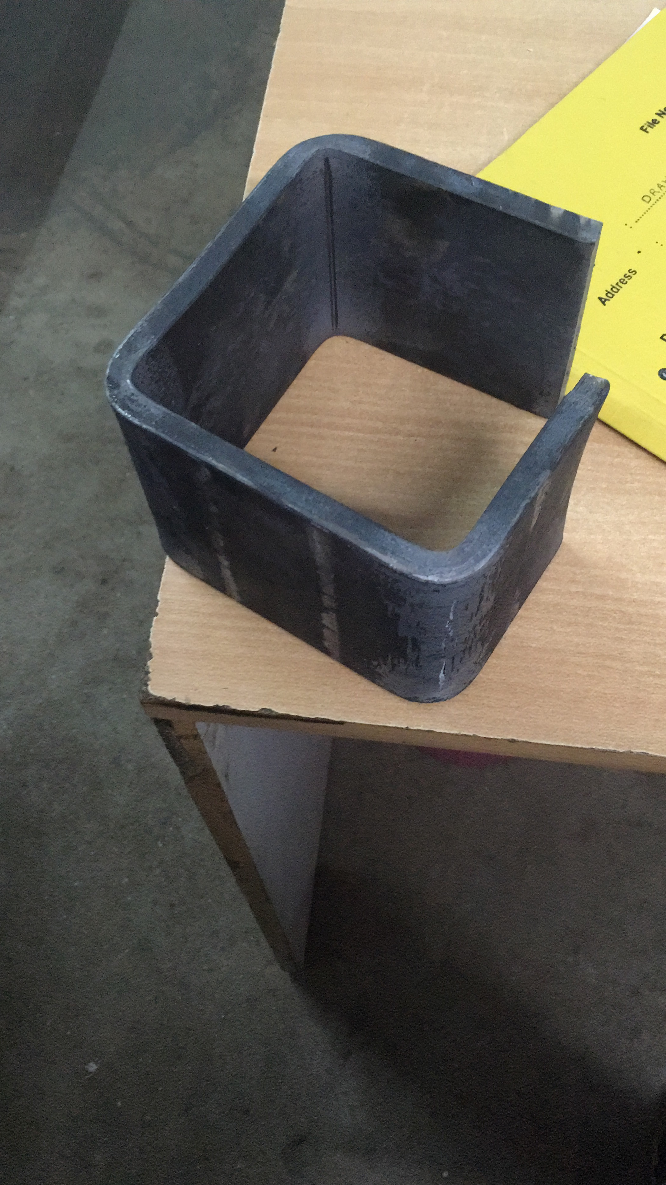

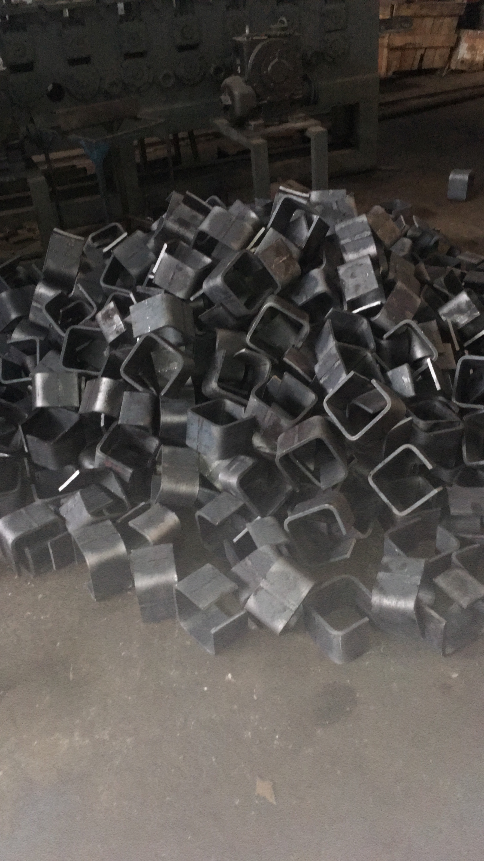

TMT/Agra /S0779/2026 07.05.2026

To,
Vivek Sharma
Gurukripa Enterprises, PLOT NO.9,
GURUKRIPA TOWN COLONY, VILLAGE-PANCHGAI KHEDA,
DEORI ROAD,AGRAVILLAGE-PANCHGAI
KHEDA PLOT NO.9 DEORI ROAD,282009,Agra, Agra - 282001, UP
Click to Call: +91-9870709589
E-mail: vivek146922@gmail.com

Dear Sir,

Sub: - QUOTATION FOR HYDRAULIC SHEARING MACHINE

Thank you very much for your enquiry regarding your requirement of Hydraulic Shearing Machine mainly for SS Sheets. We are glad to inform you that we would be in a position to supply you the required equipment. Given below are the required specifications and description of the machine and our terms and conditions.

S No | Description of the unit | Offer
1. | Hydraulic shearing machine with fixed rake angle and shearing capacity 3 Meters and 4 mm MS Sheet, along with Power pack 10.0 HP motor and other electrical fittings. | Rs 7,45,000/-
2 | NC BACK GUAGE | Rs 1,75,000/-

SPECIFICATIONS FOR THE HYDRAULIC SHEARING MACHINE WITH CUTTING CAPACITY 3000 M.M. WIDTH AND 4 M.M. THICKNESS.

1. CUTTING CAPACITY IN SS : 3000 X 4 MM.

2. RAKE ANGLE (variable) : 1.5 DEGREES

3. STROKES PER MINUTE : 12-16 Nos

4. NUMBER OF HOLD DOWNS : 13 Nos

5. BACK GAUGE ( manual) : 550 M.M.

6. MOTOR HP : 10 HP (Crompton)

- OVERALL DIMMENSIONS :

a) LENGTH : 3500 M.M.

b) BREADTH : 1200 M.M.

c) HEIGHT : 1800 M.M.

8. BED SIZE. : 3000 X 550 M.M.

9. Balade Thickness : 24 mm

GENERAL TERMS & CONDITIONS:

- Price quoted per unit ex-work. Hyderabad.
- Following charges are additional to your account.
- Freight Charge : As actual to be borne by you.
- Sales Tax : Extra as applicable
- Packing charge : As actual to be borne by you.
- Insurance : As actual to be borne by you.
- Payment : 50% advance along with order balance before delivery but after inspection at our works.
- Delivery : With 50% advance 6 weeks from date of advance received
- Validity : One month from the date of submission.
- Inspection : Inspection at our works prior to dispatch.
- Warranty : The machine is warranted for a period of 12 months from the date of dispatch against any manufacturing defects/ faulty material or bad workmanship of any part or component but not against any kind of abnormal or improper use of machine. Defective part or component will be replaced or repaired free of cost. Electrical components are outside the scope of this warranty.
- Commissioning : Erection & commissioning done by you, but required technical support & guidance provide by us at additional cost.

NOTE:
- Oil is not in scope of our supply.
- Raw material for trial is to be arranged by you at your cost.

We are sure you will find our offer in line with your requirements. Should you require any further clarification please contact 9246221106
Thanking you and assuring you of our best services

For Techno Machine Tools

( T. Sivaramakrishna)

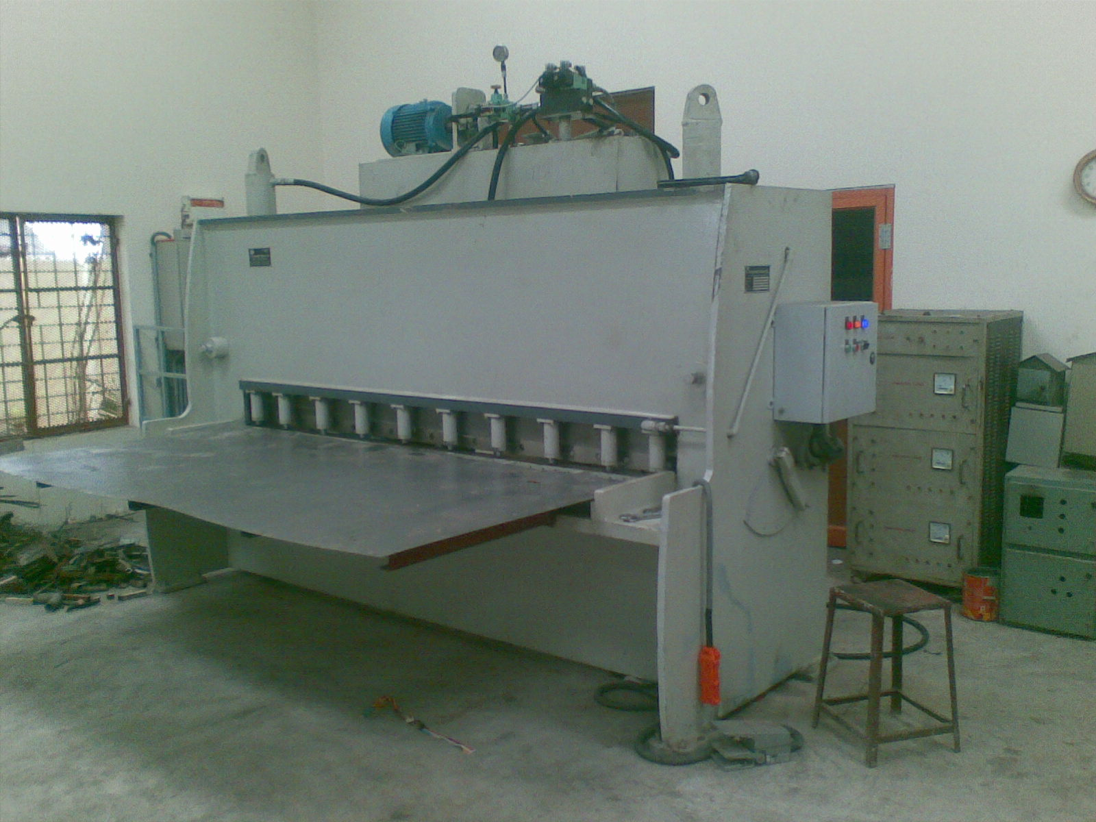

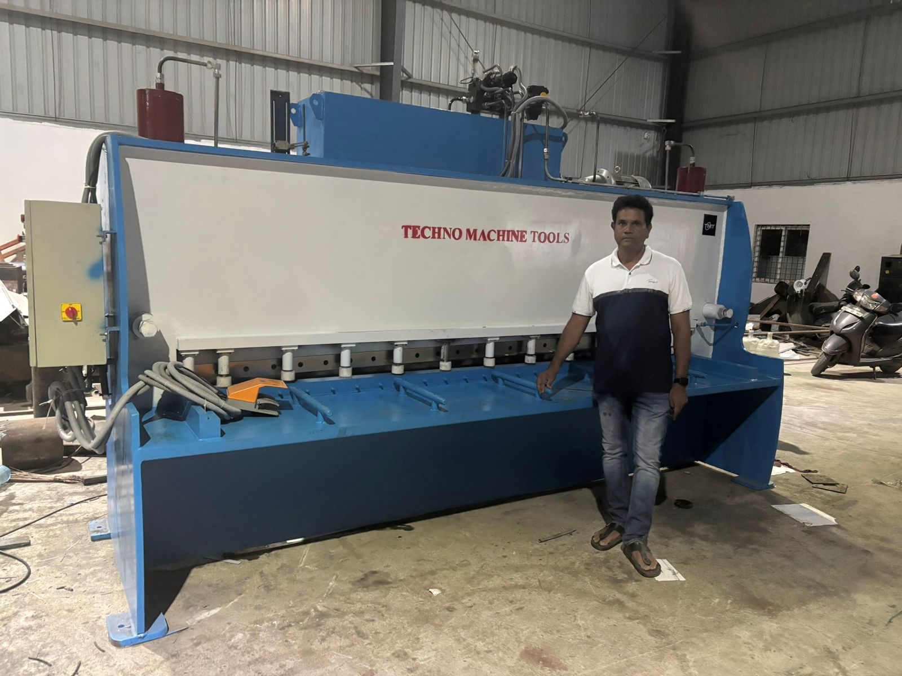

TMT/Agra /S0779/2026 07.05.2026

To,
Vivek Sharma
Gurukripa Enterprises, PLOT NO.9,
GURUKRIPA TOWN COLONY, VILLAGE-PANCHGAI KHEDA,
DEORI ROAD,AGRAVILLAGE-PANCHGAI
KHEDA PLOT NO.9 DEORI ROAD,282009,Agra, Agra - 282001, UP
Click to Call: +91-9870709589
E-mail: vivek146922@gmail.com

Dear Sir,

Sub: - QUOTATION FOR welding equipment and spares

Thank you very much for your enquiry regarding your requirement of above material mainly for Solar Sections. We are glad to inform you that we would be in a position to supply you the required equipment. Given below are the required specifications and description of the machine and our terms and conditions.

S No | Description of the unit | Offer
1. | Arc welding machines 400 amps. with welding cable, torch, head screen, black and white glasses, earthing cable (@34,000/unit) | Rs 1,36,000/-
2 | Mig welding machines along with argon cylinder adaptors welding cable, torch, head screen, black and white glasses, earthing cable (@85,000/unit) qty 4 nos | Rs 3,40,000/-
3 | Tools and takels  Spanner set (c and ring)-4 sets ( Taparia)  Testers 5 nos ( Taparia)  Allen key set – 5 boxes  Screw spanner 2 inch, 3 inch – 4 nos (2 each)  Digital vernier calipers 0-300 – 3nos (Insize)  Measureing tapes- 5 meters 10 nos, 10 meters -3 nos, bevel protractor, 0-25 micrometer, Zink coating measuring instrument and Electrical tool kit | Rs 4,50,000/-

GENERAL TERMS & CONDITIONS:

- Price quoted per unit ex-work. Hyderabad.
- Following charges are additional to your account.
- Freight Charge : As actual to be borne by you.
- Sales Tax : Extra as applicable
- Packing charge : As actual to be borne by you.
- Insurance : As actual to be borne by you.
- Payment : 50% advance along with order balance before delivery but after inspection at our works.
- Delivery : With 50% advance 6 weeks from date of advance received
- Validity : One month from the date of submission.
- Inspection : Inspection at our works prior to dispatch.
- Warranty : The machine is warranted for a period of 12 months from the date of dispatch against any manufacturing defects/ faulty material or bad workmanship of any part or component but not against any kind of abnormal or improper use of machine. Defective part or component will be replaced or repaired free of cost. Electrical components are outside the scope of this warranty.
- Commissioning : Erection & commissioning done by you, but required technical support & guidance provide by us at additional cost.

NOTE:
- Oil is not in scope of our supply.
- Raw material for trial is to be arranged by you at your cost.

We are sure you will find our offer in line with your requirements. Should you require any further clarification please contact 9246221106
Thanking you and assuring you of our best services

For Techno Machine Tools

( T. Sivaramakrishna)

